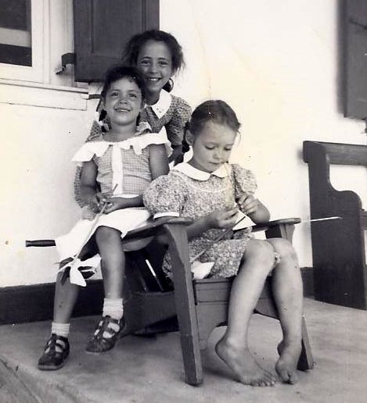
Vicky and her sister Alicia, who stayed with my Aunt Mildred and Uncle Levi Weaver. I’m the barefoot girl intent upon fixing my pinwheel.

